PENETRATION TESTING REPORT
FOOTPRINTING, OSINT & NETWORK SCANNING
NETWORKWALKS | CYBERSECURITY INTERNSHIP | WEEK REPORT

Penetration tester Name (Cybersecurity Professional) | M UBAID
Program / Batch | B084-Networkwalks
Date | 11 November 2026
Modules completed | W2-PM1 (Multiple Kali Tools), W2-PM3 (Maltego), W2-PM4 (the Harvester)
Client / Target | 1. Network walks (networkwalks.com - secured written permission)  2. Microsoft (microsoft.com - passive OSINT public sources)
Permission secured from client? | Yes (Written permission secured for networkwalks.com)

1. Liability Disclaimer
All activities described in this report were performed only within the scope of assigned educational tasks, on systems or domains for which permission was provided, or on devices and networks owned by me. The information is documented for education and research purposes only. Unauthorized access, scanning, or use of these techniques against third-party systems is not permitted. The author is responsible for ensuring that all testing remains within the approved scope.

2. Introduction
This report summarizes the practical activities completed during my NetworkWalks cybersecurity internship this week. The tasks covered information gathering and reconnaissance using Kali Linux, theHarvester and Maltego, along with network discovery using Zenmap.
The activities helped me understand how publicly available information can be collected and organized during the reconnaissance phase, and how a permitted local network can be checked for active hosts. The report explains the purpose of each tool, the work performed, the observations to be documented, possible security implications, and recommended defensive measures.
Specific output values such as discovered email addresses, domains, IP addresses, hosts and MAC addresses must be entered from my own practical results. Screenshots of the actual commands, graphs and scans should be added in the evidence section.

3. Tools Used
Tool | Purpose
Kali Linux | Linux environment used to perform footprinting and reconnaissance tasks.
theHarvester | Collect publicly available information such as email addresses, subdomains, hostnames and related sources, depending on the selected data source.
Maltego | Visualize relationships between entities such as domains, people, email addresses and infrastructure using link analysis.
Zenmap (Nmap GUI) | Run network discovery scans and view hosts and scan results through a graphical interface.
Windows Command Prompt / ipconfig | Identify the local system's network configuration, including IPv4 address, subnet mask and default gateway.

4. Activities Performed

4.1 Footprinting with Kali Linux
I used Kali Linux to perform the assigned footprinting activities. Footprinting is an information-gathering process used to develop an initial understanding of a target's publicly visible digital presence. The practical work involved using the assigned Kali tools and reviewing the information returned by each command.

4.2 Information Gathering with the Harvester
I used theHarvester to gather publicly available information associated with the assigned target. The tool can help identify information such as email addresses, subdomains, hostnames and related public sources. The collected information can help security professionals understand what information about an organization is visible online.

4.3 Visual Reconnaissance with Maltego
I used Maltego to explore and visualize relationships between the entities associated with the assigned target. Maltego presents collected information as connected entities, making it easier to understand possible relationships between domains, DNS names, IP addresses, websites and other publicly available data.

4.4 Network Discovery with Zenmap
I used Zenmap, the graphical interface for Nmap, to perform the assigned network discovery task on my own local network or another explicitly authorized network. I first checked the local network configuration using ipconfig, identified the correct subnet, and entered that subnet in Zenmap. I then selected the scan profile required by the practical, such as Ping Scan, to identify responding hosts.

5. Risk Analysis / Impact
The following are potential security observations associated with reconnaissance and network discovery. They are not confirmed vulnerabilities. Complete the evidence column using the results actually collected during the practical. associated risk levels based on footprinting observations:
# | Risk / Finding | Evidence / Observation | Potential Impact & Level
1 | Web Technology & Version Exposure | What Web identified WordPress 7.0.4 and WP Download Manager 3.3.58 | Attackers match exact version numbers against public exploit databases (CVEs) to launch target-specific exploits.  Level: Medium
2 | Public Server IP Exposure | Nslookup & WhatWeb resolved domain to 192.232.216.135 | Direct IP knowledge allows attackers to bypass domain-level DNS protections and launch direct port scans.  Level: Low
3 | REST API & HTTP Header Leakage | Curl revealed Apache banner, Nginx cache, and /wp-json/ endpoint | Exposing API endpoints (/wp-json/) allows user enumeration and structured endpoint mapping.  Level: Low
4 | WAF Architecture Identifiable | Wafw00f detected ModSecurity (SpiderLabs) WAF | Informs attackers that standard payload signatures will be blocked, prompting WAF evasion techniques.  Level: Low
5 | DNS & Mail Infrastructure Mapping | DNSRecon mapped MX, SPF (websitewelcome.com), and cPanel SRV records | Exposes mail routing, DNS server software versions (Bind 9.16.23), and hosting backend infrastructure.  Level: Medium
6 | Organizational Email Address Harvesting | Maltego & theHarvester discovered info@networkwalks.com & viva-noreply@microsoft.com | Harvested emails provide direct targets for spear-phishing, social engineering, and credential stuffing attacks.  Level: Medium

Risk levels should be assigned only after reviewing the actual evidence and the organization's context. Reconnaissance results alone do not prove that a system is vulnerable. No exploitation or vulnerability validation should be claimed unless it was explicitly performed and authorized.

7. Conclusion
During this week's NetworkWalks cybersecurity internship tasks, I practiced reconnaissance, OSINT and network discovery using Kali Linux, theHarvester, Maltego and Zenmap. I learned how theHarvester can collect publicly available information, how Maltego can display relationships between entities, and how Zenmap can help identify active hosts on an authorized network.
These activities improved my understanding of the reconnaissance stage of a security assessment. They also showed the importance of recording the exact commands, scan scope, observations and supporting screenshots. The findings in a report must be based on actual tool output, and information gathering must always remain within the permission and scope provided.

8. Evidence Collected

Evidence 1 – Kali Linux footprinting commands and results
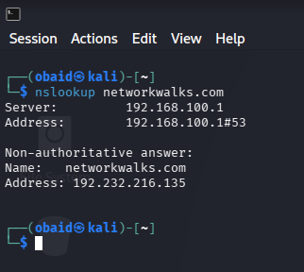
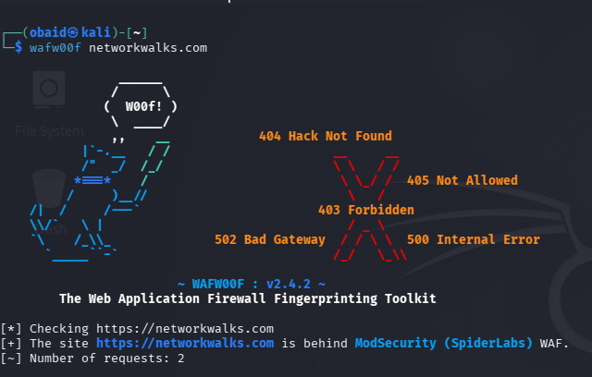
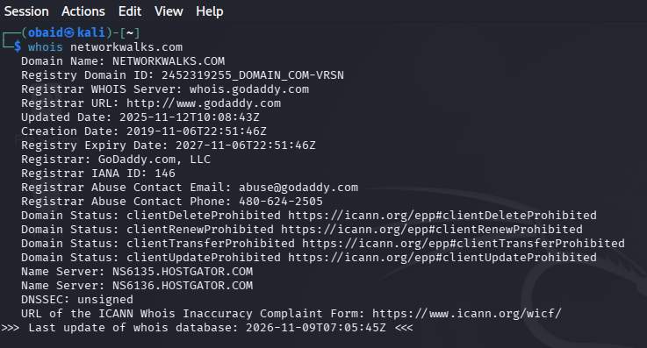
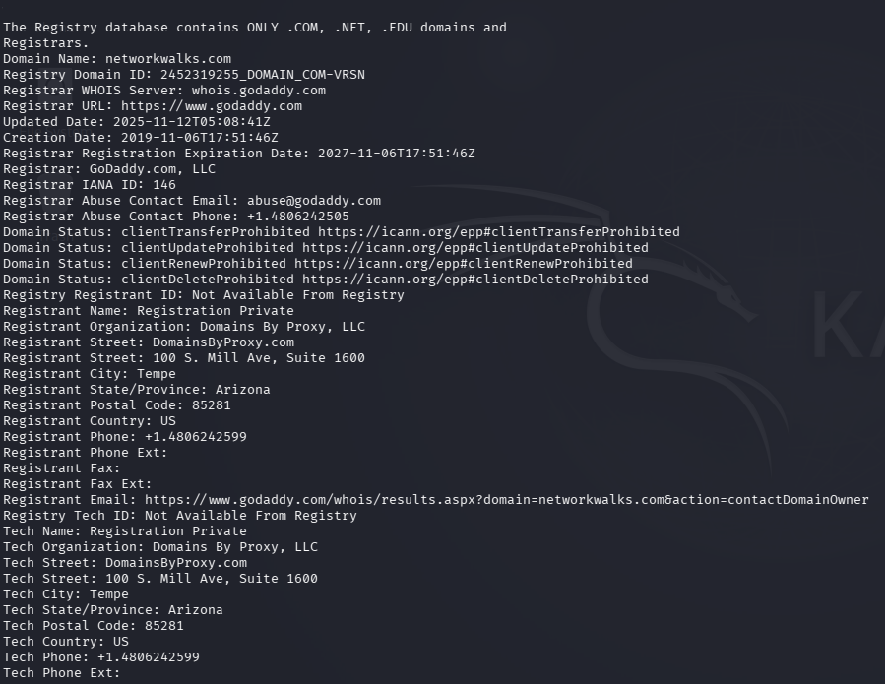
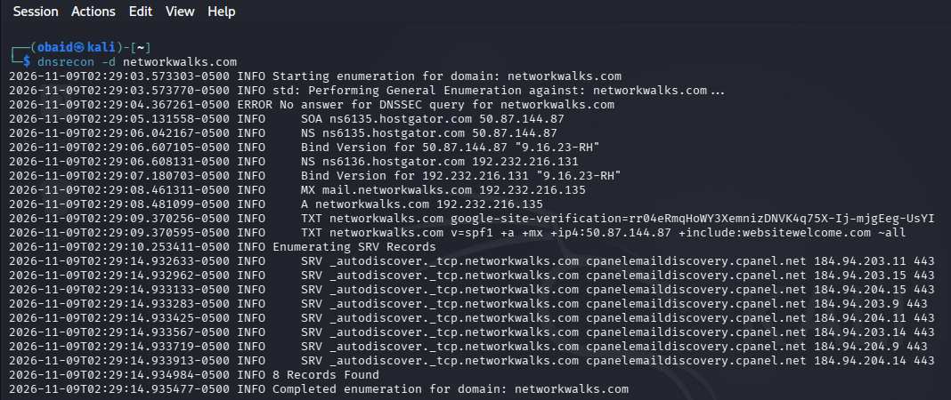

Evidence 2 – the Harvester command and output

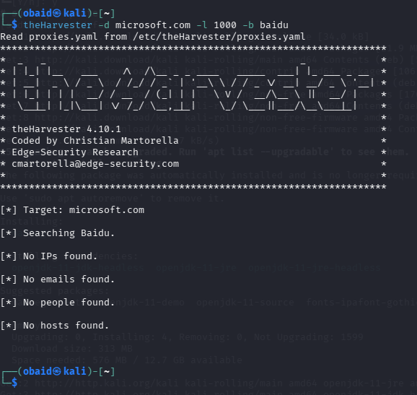
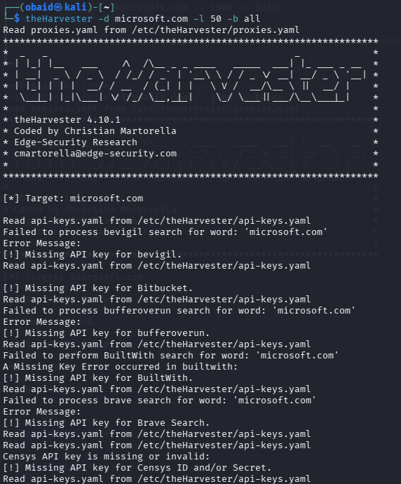
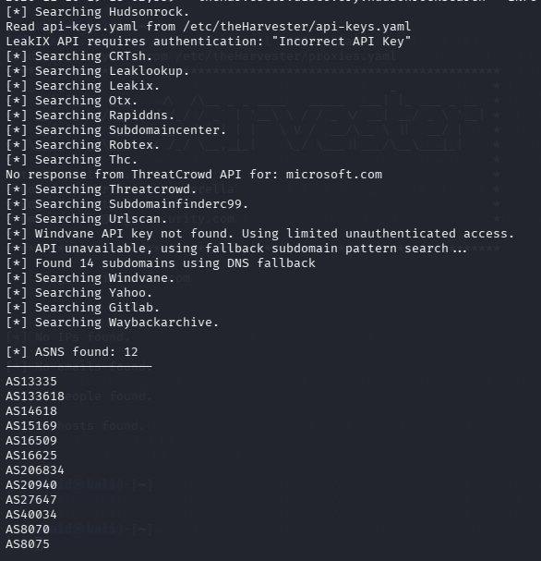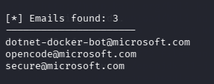
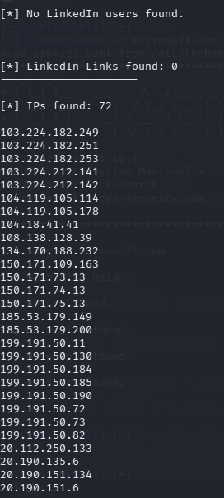

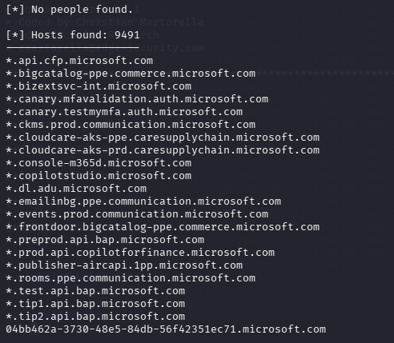
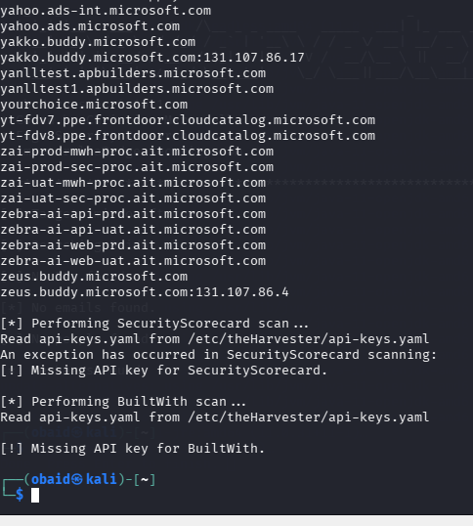

Evidence 3 – Maltego graph / entities and relationships
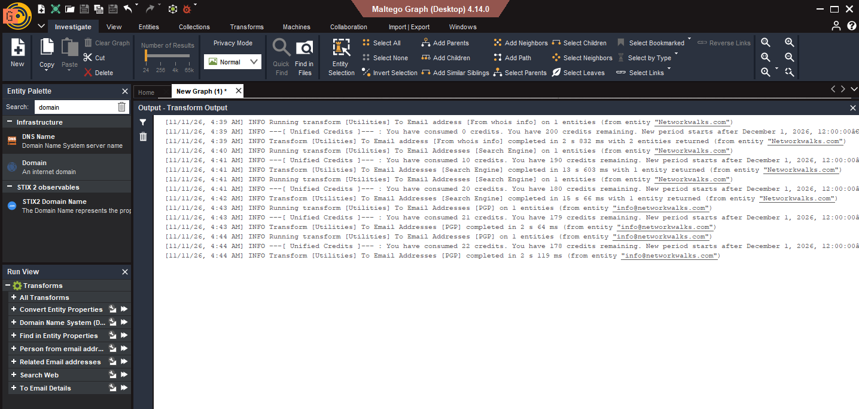
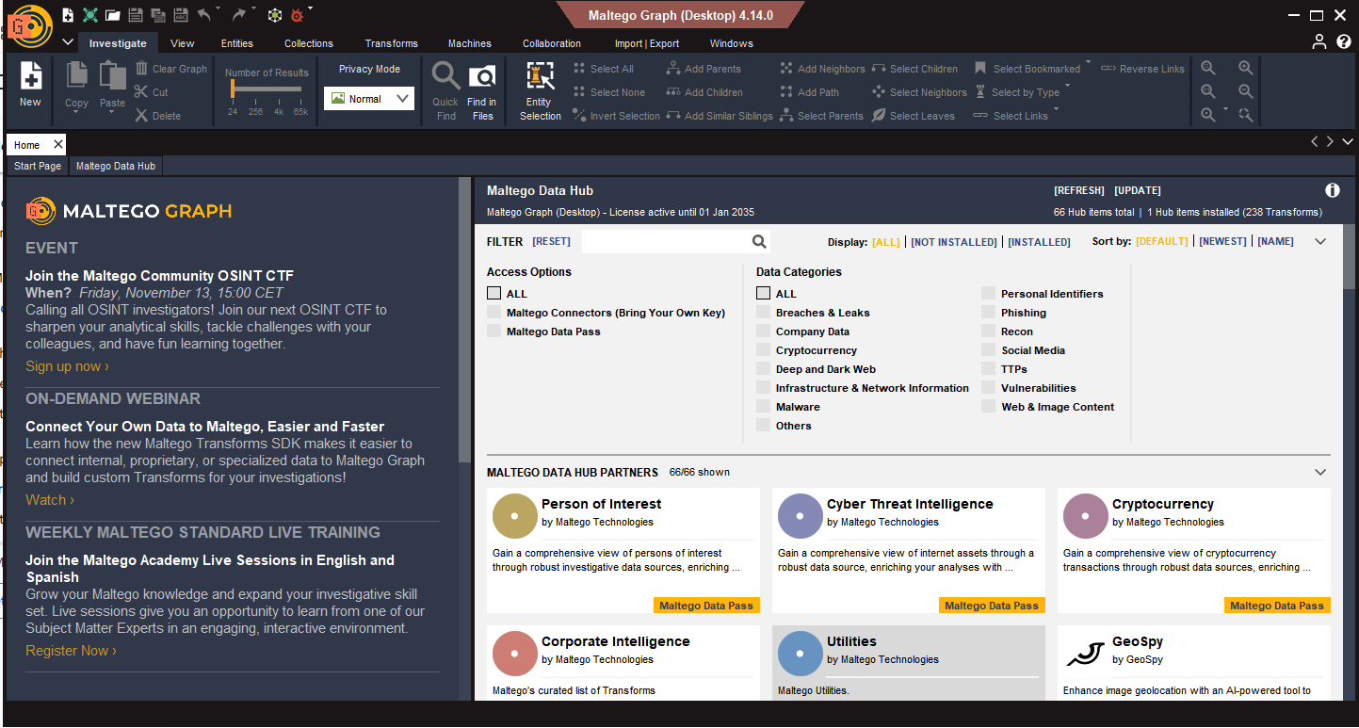
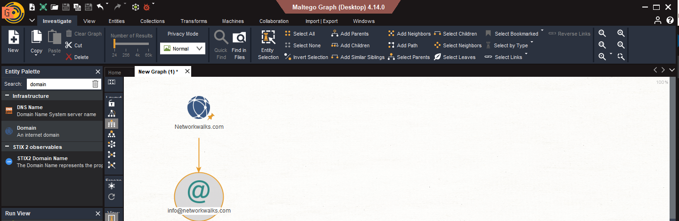

Evidence 4 – Zenmap scan profile and host discovery results

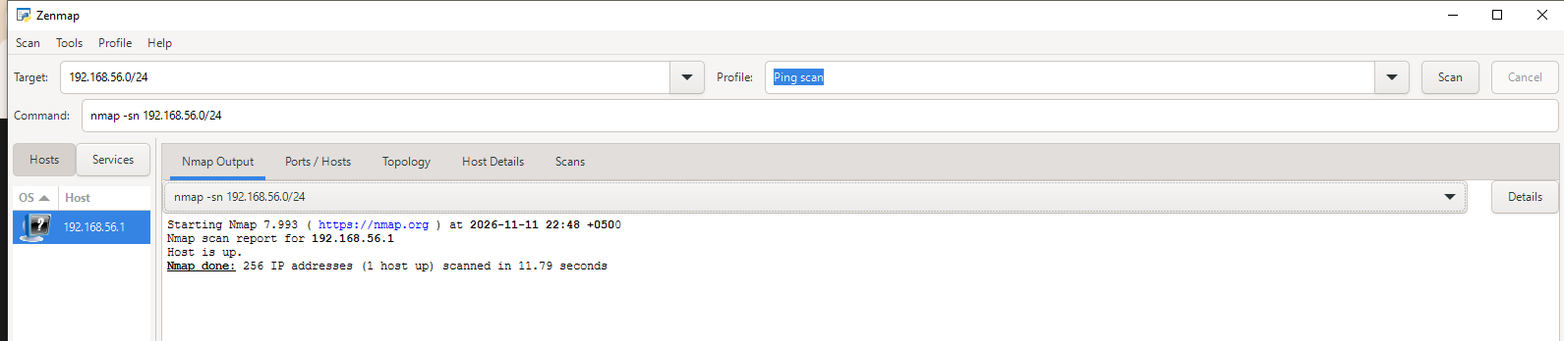

Evidence 5 – Zenmap topology view or exported topology
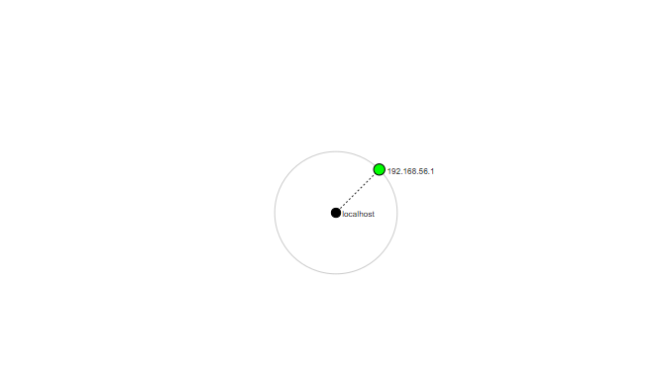
the pdf couldn’t be uploaded.
- End –

Author
M. Ubaid
Cybersecurity Intern | NetworkWalks

